**STATUS REPORT: WEEK 8.**

MSIS720 – IS Project (DegreeWorks)

**Vision & Mission Statement:**

"Empowering students with an innovative DegreeWorks platform for clear, efficient academic planning and progression."

**TEAM 4 :**

ADLA MOUNIKA.

CHALLAGALLA SIVA NAGA SOWMYA.

GUDIMILLA NAVEEN KUMAR.

LAKKIREDDY PAVAN KUMAR REDDY.

YASA ABHINAYA.

|  |  |  |
| --- | --- | --- |
|  | * Created Student Credits view and status page. |  |
|  | * Preparing Data for all the pages and planning sequence of steps to know what to include in specific page. * Working on Student Subject page |  |
|  | * NONE |  |
|  | * Created flowchart of workflow, in designing degree work application prototype (Week 7) * Designed Home Page & Profile page (Week 7) * Created Homepage for Degreeworks application, gives us a theme to further pages. (Week 6) * Did survey successfully we got around 25 responses did a strategic analysis and figured out needs and requirements. (Week 5) * Prepared questions on User interface and Functionality and future preferences. (Week 4) * Created Microsoft Forms to conduct Survey (Week 3) * Finalised – Prototype, preparing dashboard, gathered info to prioritize content (Week – 2) |  |

**Home Page:**

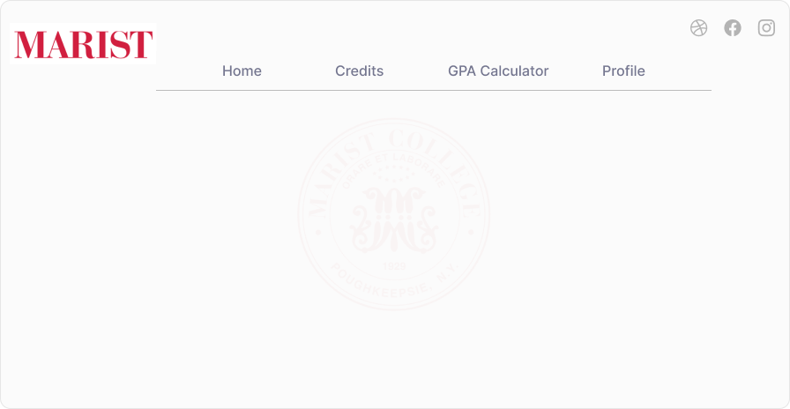

**Credit Page:**

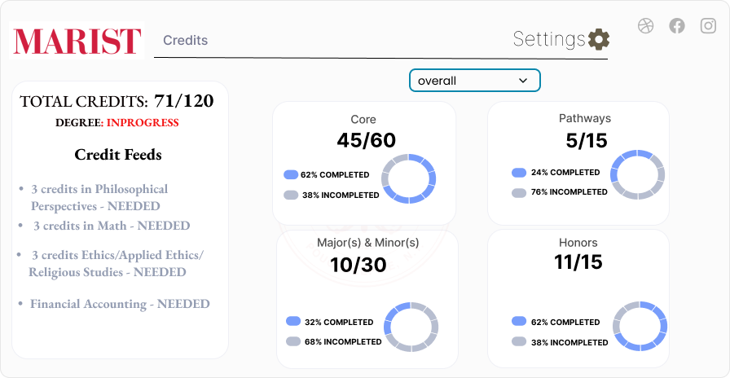

**Page Highlights:**

**1.Problem Statement:** The purpose of the credit usage page. Clearly aims to Simplify for graduate student’s credit viewing experience.

Managing credits effectively, this design setting addresses this need.

**2.Data Visualization:** Presenting credit distribution Progress using PIE. How credits are allocated across courses, majors, and minors.

This design helps students quickly grasp their credit status.

3.**Key Elements:**

* Hover effects: Additional information when hovering over credit details.
* Filters: Allowing students to filter credits by semester, type, or category.
* Drag-and-drop: Enable students to rearrange courses or adjust credit allocations.

